## Vision Statement

*Before Legends is a PC 3D single player round based combat game. The player takes control of a prehistoric hero whose goal is to avoid starvation and collect resources in a hex-based procedurally generated map. Battles are resolved activating special attack cards which can be bought with the map´s resources.*

### USPS

* Rarely explored prehistorical setting
* Appealing card & board-game feel
* Highly customized procedurally generated maps

## Gameplay Overview and Player Tasks

* The protagonist

In Before Legends the player takes control of “The Hero”, a strong prehistoric human that roams the game´s word.

* Movement and rounds

The Hero can move on the hexagon based map up to 4 tiles. After The Hero consumes all of his moves, the round ends and the AI takes over.

During the AI´s turn all enemies can move (enemies will usually move towards The Hero) and potentially attack him if they reach his tile. Some map resources might be respawned.

* Win & Loss conditions

Losing the game

The player is constantly challenged by the threat of starvation and by the opponent monsters competing with for survival in every corner of the world.

Starvation occurs, if the player has no food left in the resource inventory. For each turn with this condition the player’s unit suffers HP penalty equal to 20% of the default maximum HP. If the HPs drop to 0, the player has lost the game. On the other hand, as long as there is food in the resource inventory, the player recovers HP equal to 10% of the default maximum HP per turn.

Most opponents will actively challenge the player in battle, if they have the chance. Losing a single battle will also end the game with defeat. This harsh rule aims to enforce the primeval feeling of the game – one bad decision decides between life and death. But the player has enough tools to wisely avoid such perils:

* + the special combat cards acquired by spending collected resources give significant advantages to the player in battle;
  + the level system rewards the player with significant stats boosts (bonus on attack, armor and HP) for each level progressed through experience;
  + the difficulty level of the opponents is always visible to the player on the world map (3 difficulty levels indicated by respectively one, two or three stars) so that a decision can be made between attacking or avoiding an opponent;
  + all opponents have less movement points per turn than the player, so that escape is always an option worth attempting;
  + not all opponents will hunt the player actively, some of the strongest monsters in Before Legends – the Mammoths – will never actively pursue the player and will be of threat only if the player ends his/hers turn next to one of them and have the bad luck of the Mammoth going exactly in their direction during his turn.

Winning the game

At the beginning of each game the player can set which victory conditions will affect that session, these are:

Civilization Builder:

* Collect 100 food
* Collect 50 wood
* Collect 50 stone

Path to Glory

* Collect 3000 glory

### Breakdown of Player Activities (Pie Chart)

## The World Map (Strategic)

The world map of Before Legends is procedurally generated at the beginning of each game session which means that no two game maps are the same. The Customizable values are:

* Map Size : small, medium, large
* Temperature: from mostly artic to predominantly tropical
* Altitude: from flat to very mountainous
* Humidity: very dry to very wet climate

Combining these values produces a map which has different percentages of the various types of tiles. Different tiles contain different spawn percentages for resources and monsters.

Overview of the map generation based on the input from the player in the beginning of the game on the three categories (altitude, humidity, and climate) and the resulting terrain variations (Table 01), as well as the chances of resources being spawned on them (Table 02):

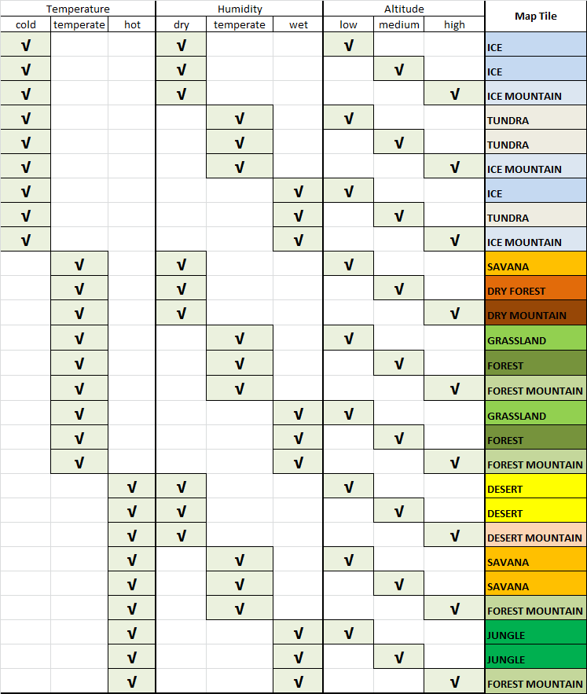 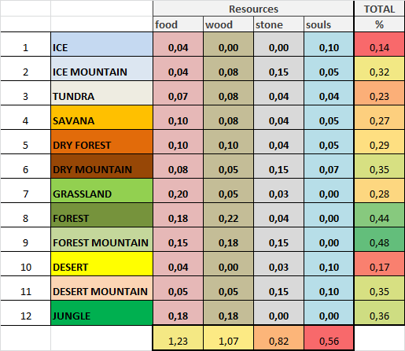

Table 01 Table 02

The Resources

In Before Legends the Hero can find 4 different types of resources as he explores the map:

* Food:
  + the most frequent resource,
  + present in most types of tiles, rare only in “extreme” environments (eg desert)
  + necessary to avoid starvation (when the counter goes down to zero)

- Wood, easy to find

* + easy to find
  + mostly available in environments that would have trees (such as forest)
  + needed for all Battle Cards

- Stone,

* + on average more rare than the other resources
  + spawns … FILL HERE (ASK TOMA)
  + needed for all Battle Cards

- Souls,

* + the rarest resource
  + spawns mostly in “inhospitable” tiles such as desert or tundra
  + needed for battle cards with supernatural effects (eg Heal or Shield)

Resources as shown as map elements and each occupies one tile. Moving The Hero into a tile with a resource will automatically add the resource to his inventory (visible on the upper right).

* Glory,

A special resource available to the player, glory stands equivalent to the experience that the player gains after defeating opponents in battle and cannot be obtained in any other way. Each opponent type will reward to player with different amount of glory, depending on the difficulty level of the opponent, so obviously the stronger the opponent and thus the risk for the player, the higher the amount of glory that can be received after defeating the opponent. The glory is not only essential for the victory condition “Path to Glory”, but also allows the further level progression for the player. Every next level gives significant bonus to the attack, damage and HP stats of the player’s unit, thus making him stronger in battle.

## The Battle Map (Tactical)

Combat Mechanics

When the player attacks an opponent, or is being attacked by one, the game is switched to the combat screen, which is a different layer than the one from the world map:

|  |  |
| --- | --- |
| World Map | Combat map |
|  |  |

The combat map layer of the game is also turn based with the player always having the first move. The player can chose between six actions represented by the six combat cards in the bottom side of the screen. The first action is the basic attack of the player’s unit and has no limit on how often it can be used. All other five actions are however limited and spent by use. Special combat cards can be acquired by the player in the shop in the world map by spending resources. After every action of the player, there is a reaction from the opponent. All opponents have, beside their standard attacks, special actions too, which are triggered by the AI under various conditions, in order to provide great variety for the player during combat.

The UI is designed to offer the player maximum information on the battle at any time and with one glaze over it. Damage is always shown after an attack is executed, the HP’s and the combat stats of both the player’s and opponent’s units are always visible in the left and right corner of the screen and in the bottom right corner of the screen the player has the option to open and close a battle log containing detailed information on every action/reaction during battle, if the player wishes more detailed feedback.

## The Battle Map (Tactical)

If The Hero moves to a tile with an enemy the game switches from the world map to the battle map. At this level the games moves to a more tactical layer with each action each round being crucial for the success of the battle.

The Round System Battle

* Battles are always 1vs1 and
* the player can play just one card during his round
* the enemy acts always after The Hero
* the enemy can take just one action as well

The Statistics

Both The Hero and its enemies have numeric values to show how strong they are (the once in *italic* are hidden from the player):

* AS (Attack skill) “The skill of a unit to successfully attack and injure the enemy”
* DS (Defense Skill) “The skill of a unit to protect himself from the attack of the enemy”
* D (Damage) “The basic level of injury the unit can cause with his weapon on the health of the enemy unit”
* A (Armor) “The physical protection of a unit from the damage inflicted by the enemy in his attack. Armor has a negative correlation with AP.”
* HP (Hit points) “The amount of inflicted damage a unit can take before being killed”
* AP (Action points) How many activities can a unit perform within 1 turn during battle. this is a legacy of a previous development stage and are just used for enemies special attacks.
* Critical Strike: there is a random chance that an attack deals much more damage than usual

This is how damage is calculated when The Hero or an enemy attacks:

* MAD (Multiplication on damage (D)) “The success of the attack of a unit in relation to his AS vs the DS of the enemy. Has impact on the D.”
* MAD = (AS / DS)/10
* if AS > DS , then MAD = (+)
* if AS <= DS, then MAD = (-)
* DV (Damage Value) “The value of the damage from an attack in relation to the MAD”
* DV = D + (D x MAD)
* HPP (Hit points penalty) “The final value which will be subtracted from the HPs of a unit after he is attacked. Defined by the DV in relation to the A.”
* HPP = [DV / (DV + A)] x DV

The Cards

These are the effects of the Battle Cards that The Hero can use in battle

|  |  |  |  |  |  |
| --- | --- | --- | --- | --- | --- |
| Card | Dmg | healed | range | additional | description |
| Attack | 1 |  | ±0,2 |  | Basic weapon hit |
| Wrath | 2 |  | ±0,5 |  | Powerful blow |
| Stun | 0,3 |  | ±0,1 | stuns | Enemy looses next action. |
| Heal |  | 0,4 | ±0,1 |  | Heals up to half HP |
| Revenge |  |  |  | mimics damage | Reflects received damage |
| Shield |  | 0,15 | ±0,05 | shield | Absorbs next attack |

## Obstacles & Opponents

Apart from The Hero, other creatures roam the wildlands of Before Legends:

* The Mammoth, which covers the role of “slumbering giant” in Before Legends
* The Horned Lion, this is the most approachable enemy in the game
* The Jackal-men, direct competitor of humans in the food chain (and therefore of The Hero)

Depending on the different environments in which they spawn, their textures (and stats) vary. These combination of environments and types of enemies generates the variety below:



The Artificial Intelligence

In the World Map:

* Horned Lions always come for The Hero
* Jackal-men hunt The Hero with an even larger detection range
* Mammoths move slowly ignoring The Hero

In Battle



Other Obstacles for The Hero:

* Extreme terrains such as desert or arctic have less food
* Water and land bottlenecks can force the player close to monsters or foodless areas

## Player Progression & Pacing

The Hero can grow and progress during the game. He starts at level 1 and can grow up to level 5.

The Hero needs to be about the same level as the number of stars above an enemy in order to beat it without too much risk.

Player progression:

|  |  |  |  |  |  |  |  |
| --- | --- | --- | --- | --- | --- | --- | --- |
| **lvl** | **Glory** | **Gl step** | **HP** | **Damage** | **Armor** | **Attack** | **Def** |
| **1** | 0 | 400 | 20 | 6 | 2 | 3 | 2 |
| **2** | 400 | 1500 | 25 | 9 | 4 | 3 | 2 |
| **3** | 1900 | 3000 | 30 | 11 | 6 | 3 | 2 |
| **4** | 4900 | 5100 | 35 | 14 | 8 | 3 | 2 |
| **5** | 10000 |  | 40 | 17 | 10 | 3 | 2 |

## Setting & Story

A few key points about the setting of Before Legends

* It´s distant in time and space but still reminiscent of our past
* It´s similar to our world but somehow detached as well
* It´s very dangerous and inhospitable, not a place for human beings

About the

## Visuals

Before Legends art is influenced by a few key goals we want to achieve:

* Providing the “primal” feel
* The game must feel “epic”
* The environment must feel familiar but at the same time legendary and distant in time
* We wanted the gameplay and art to feel organically connected

Another important element art-wise is our decision to have two distinct scenarios, the world and the battle map. We did not want the two maps to be the same neither to feel too disconnected from each other.

We tackled all these goals through a few pivotal decisions:

* The world map has a distinct board game feel:
  + The hexagon tiles are clearly distinguishable
  + Environments on tiles are hand-drawn like on an actual board game
  + The Hero and its enemies models are on bases like game miniatures
  + The various models slide like miniatures
* The battle map has a more realistic feel:
  + The scene happens by night, feels darker and less safe
  + The rocks and the stone surface are, though stylized, very detailed
  + The spears and skulls provide a more gritty and dramatic atmosphere
  + The mist and the cloud shrouded moon give a mystic touch to the scene

Apart from The Hero´s model, which is based on the traditional white male hero conventions, there are other 3 opponent models, each filling its own game-role:

* The Mammoth, which covers the role of “slumbering giant” in Before Legends
* The Horned Lion, this is the most approachable enemy in the game
* The Jackal-men, direct competitor of humans in the food chain (and therefore of The Hero)

Art-wise, the thinking behind was:

* Defense Of The Ancients (DOTA 2) is the main character reference
* Before Legends will be less colorful than DOTA 2
* The artists aimed for a comic feel yet still somehow realistic
* Animals are a mixture of different species in order to make the world feel more distant:
  + The Jackal-folk are a mix of canid and humanoid features
  + Before Legends Mammoth are part elephant part insect
  + Lions have powerful horns like a Buffalo

Regarding the User Interface

* The Main goal was to achieve a primal but “heavy metal” look as well:
  + Bones, rocks and sharp ends were used to achieve this
  + The menus tend to look sandy and “dirty”
  + Many jagged edges.
* Some degree of physicality was given to the menu as well
  + Some menus look like stretched animal skins
  + Some elements such as the battle cards are visibly made of stone

## Music & SFX

There are two main tracks for Before Legends, a world map track and a battle map one

The world map track

* The use of violins and film soundtrack like orchestra gives it an epic feel
  + The drums on the background relate to the “tribal” feel
* The music is obviously conceived to be looped without being too annoying

The Battle map´s track

* Drums are used to keep up the pace and induce some fear
* The melody is faster
* Male voices on the background contribute to the tribal feel

Regarding sound effects

* Sounds of stones were often used for the “stone age feel”
* As a guideline sounds are kept as closest as possible to their real-world counterpart

## Target Group & Platform

Before Legends is a PC game. Due to the platform and the gameplay we expect the game to appeal to a mid and hard core audience.

As it lacks a save system and with its perma-death, each session of Before Legends is a small challenge. The relatively simply combat system though compensates in order not to make the game unreachable for more mid-core players.

Our board and card game graphic contributes to attract a more hard core crowd as the game might appear immediately familiar to tabletop gamers.

## The Team – The Bonfire Elders

Team members and tasks:

|  |  |
| --- | --- |
| Allan Cudicio | Game Design |
| Amon Kalagin | 3D Art |
| Toma Komitski | Game Design |
| Raphael Koller | 3D Art |
| Benjamin Koß | Programming |
| Viktor Pekar | Producing |
| Andreas Pinternagel | 2D Art |
| Daniel Pochert | Programming |
| Samir Riecke | 3D Art |
| Manfred Tausch | Music |
| Luke Ulke | Programming |
| Markus Zierhofer | Music |

Marcel Benes aided the team with art consultations.

## Development Tools

Apart from the game´s engine Unity 5, the tools used for Before Legends development are

Game Design

* Word for most documents
* Excel to balance variables and for battle simulator

2D Art

* Photoshop for concept art and UI
* Pen & Paper for concept art
* Illustrator for Logo
* InDesign for Cover

3D Art

* Blender for modelling/rigging/animation
* 3Dmax modelling
* ZBrush sculpting
* Knalt & Xnormal for map baking
* Photoshop
* Maya for animations
* Crazybump for baking

Producing

* Omniplan for time management
* Omnifocus for task breakdown
* Excel for project management and miscellaneous organization
* Evernote for meeting reports

## Timeframe & Critical Points